**TASK 1**

#include <iostream>

using namespace std;

int main()

{

int num,sum=0;

for (int i=1; i<=10; i++) {

cout<<"number "<<i<<": ";

cin>>num;

sum += num;

}

cout<<"Sum of ten numbers is "<<sum;

}

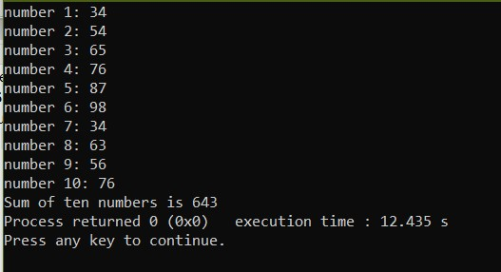

**TASK 2**

#include <iostream>

using namespace std;

int main()

{

int num;

cout<<"Input a number: ";

cin>>num;

cout<<"Table of "<<num<<endl;

for (int i=1; i<=10; i++) {

cout<<num<<" x "<<i<<" = "<<num*1<<endl;

}

}

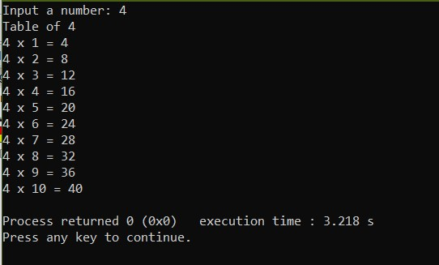

**TASK 3**

#include <iostream>

using namespace std;

int main()

{

int num, factorial;

cout<<"Input a number: ";

cin>>num;

factorial = num;

for (int i=num-1; i>0; i--) {

factorial *= i;

}

cout<<"Factorial of "<<num<<" is "<<factorial<<endl;

}

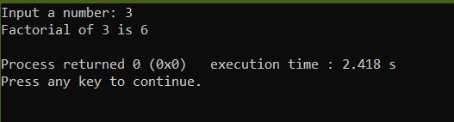

**TASK 4**

#include <iostream>

using namespace std;

int main()

{

int prev, next, stop, sum;

cout<<"Sequence number 1: ";

cin>>prev;

cout<<"Sequence number 2: ";

cin>>next;

cout<<"Length of sequence: ";

cin>>stop;

cout<<prev<<", ";

cout<<next<<", ";

sum = prev + next;

cout<<sum<<", ";

for (int i=4; i<=stop; i++) {

prev = next;

next = sum;

sum = prev + next;

cout<<sum<<", ";

}

}

